Workspace Setup DOC

## Steps for Java Workspace Setup

1. Download the Summer_Intership_Backend and extract the folder.  
   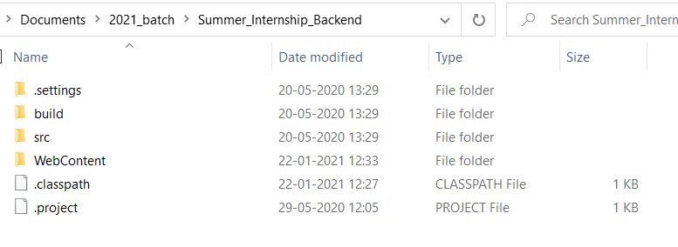
2. Create a folder named workspace and make it as an eclipse workspace.  
   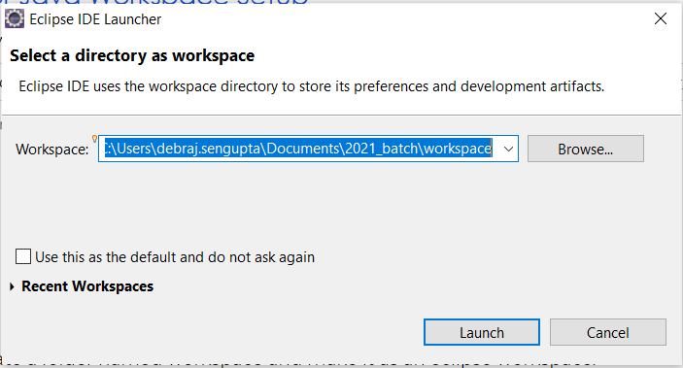
3. Open Eclipse -> go to File -> import -> General -> Existing Project into workspace -> next -> Browse downloaded folder -> Finish.  
     
   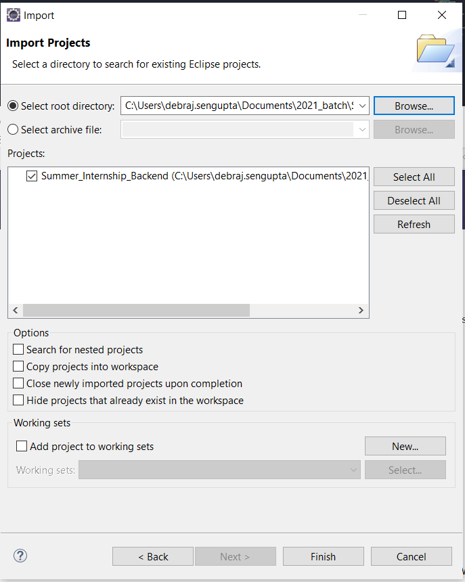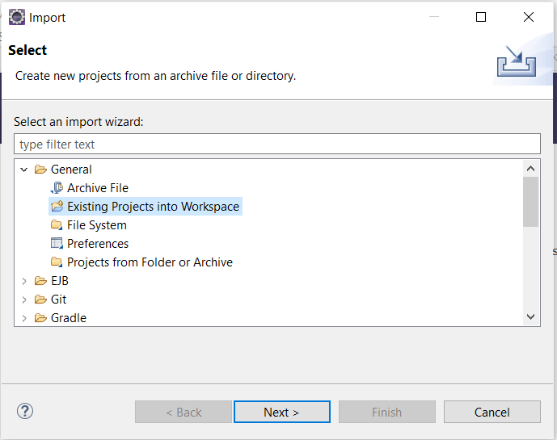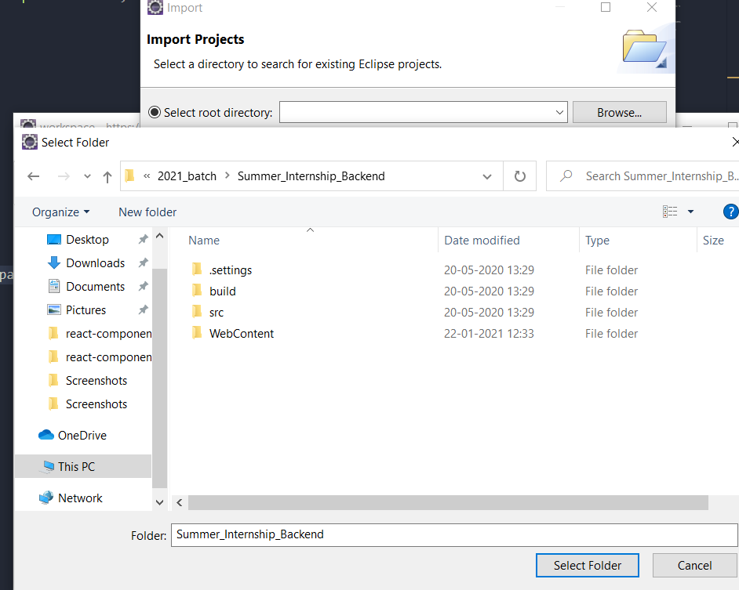
4. Right click on Project -> Build Path -> Configure Build Path  
   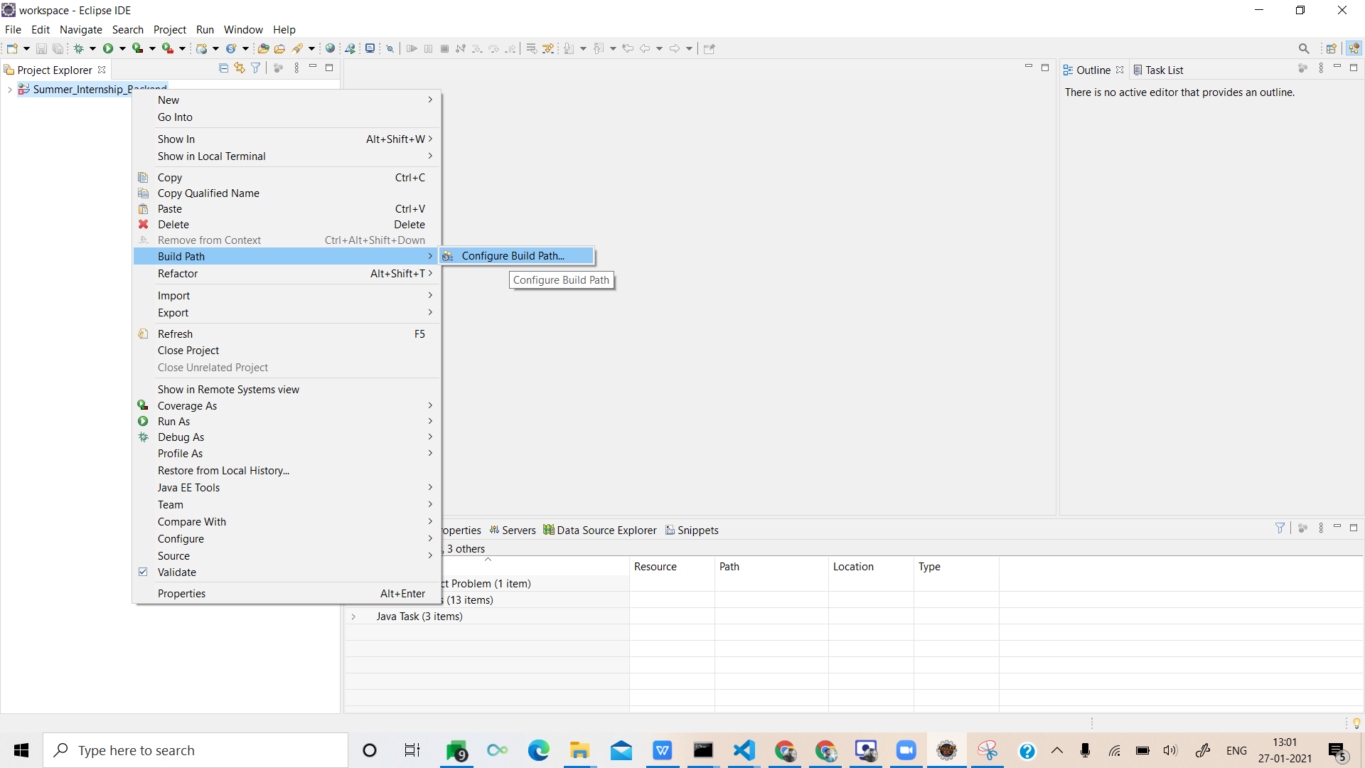
5. Select Libraries tab in opened popup -> JRE System Library -> Edit -> Workspace default JRE -> Finish -> Apply -> Apply and close  
   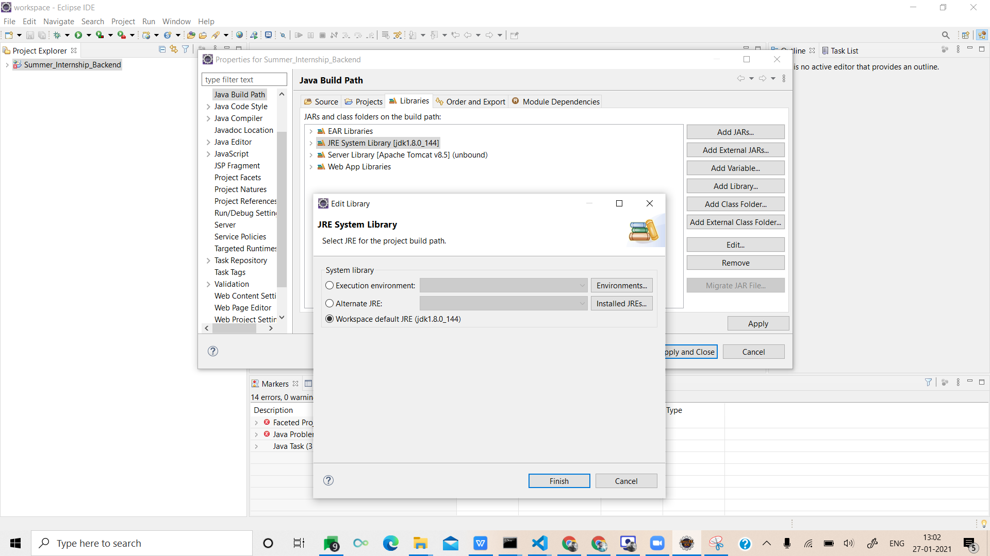
6. Select Servers tab in Show View -> Click on “No servers are available. Click this link to create a new server” -> Select Tomcat v8.5 Server from   
   Apache dropdown -> next -> browse and select given apache-tomcat-8.5.55 folder -> next -> select project -> add -> finish.  
   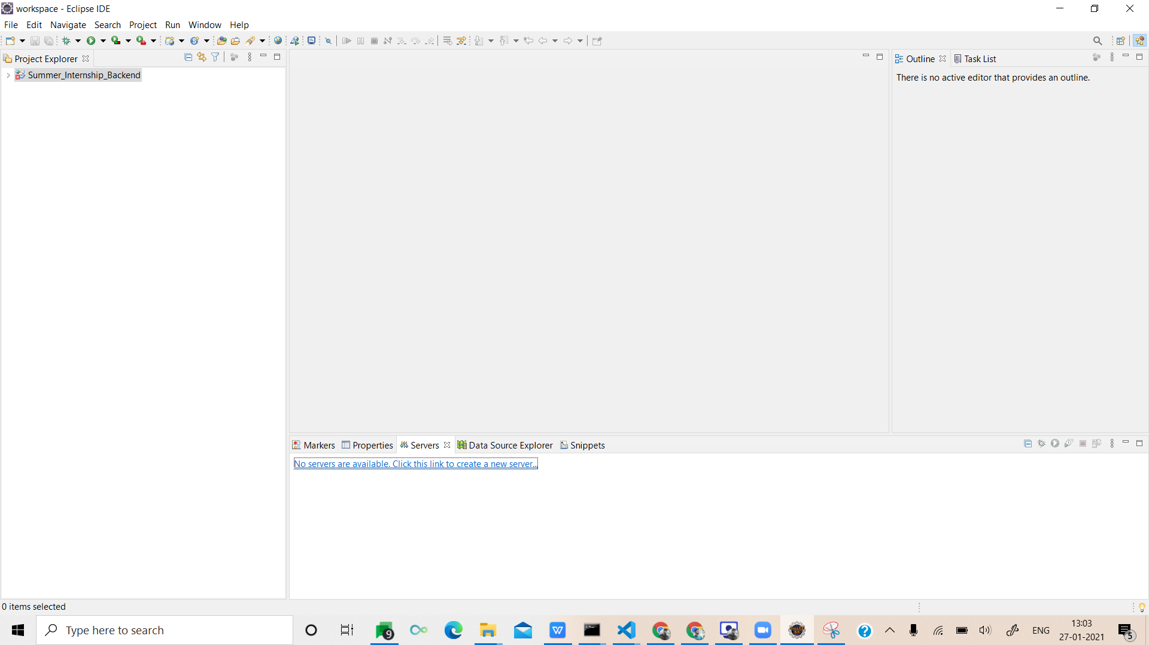  
   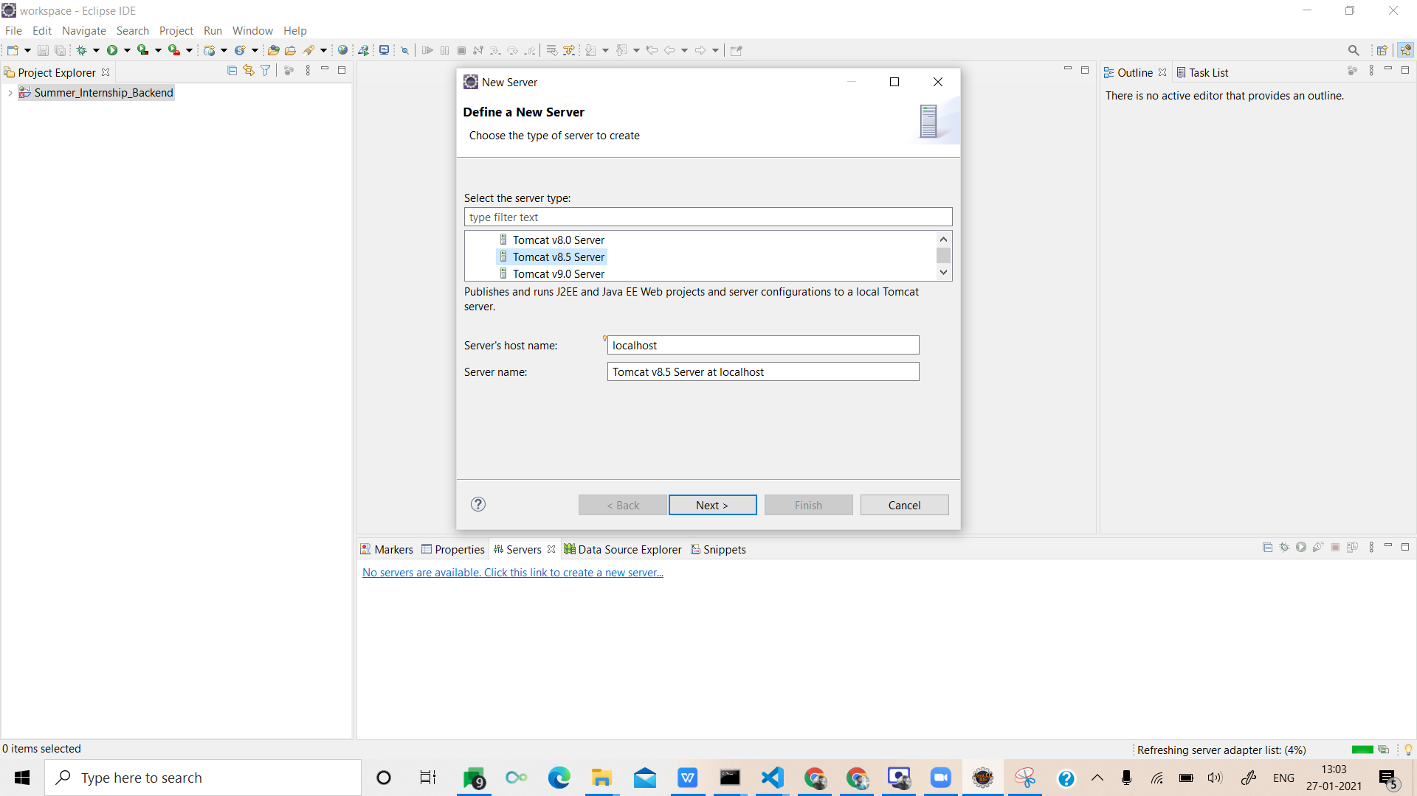  
   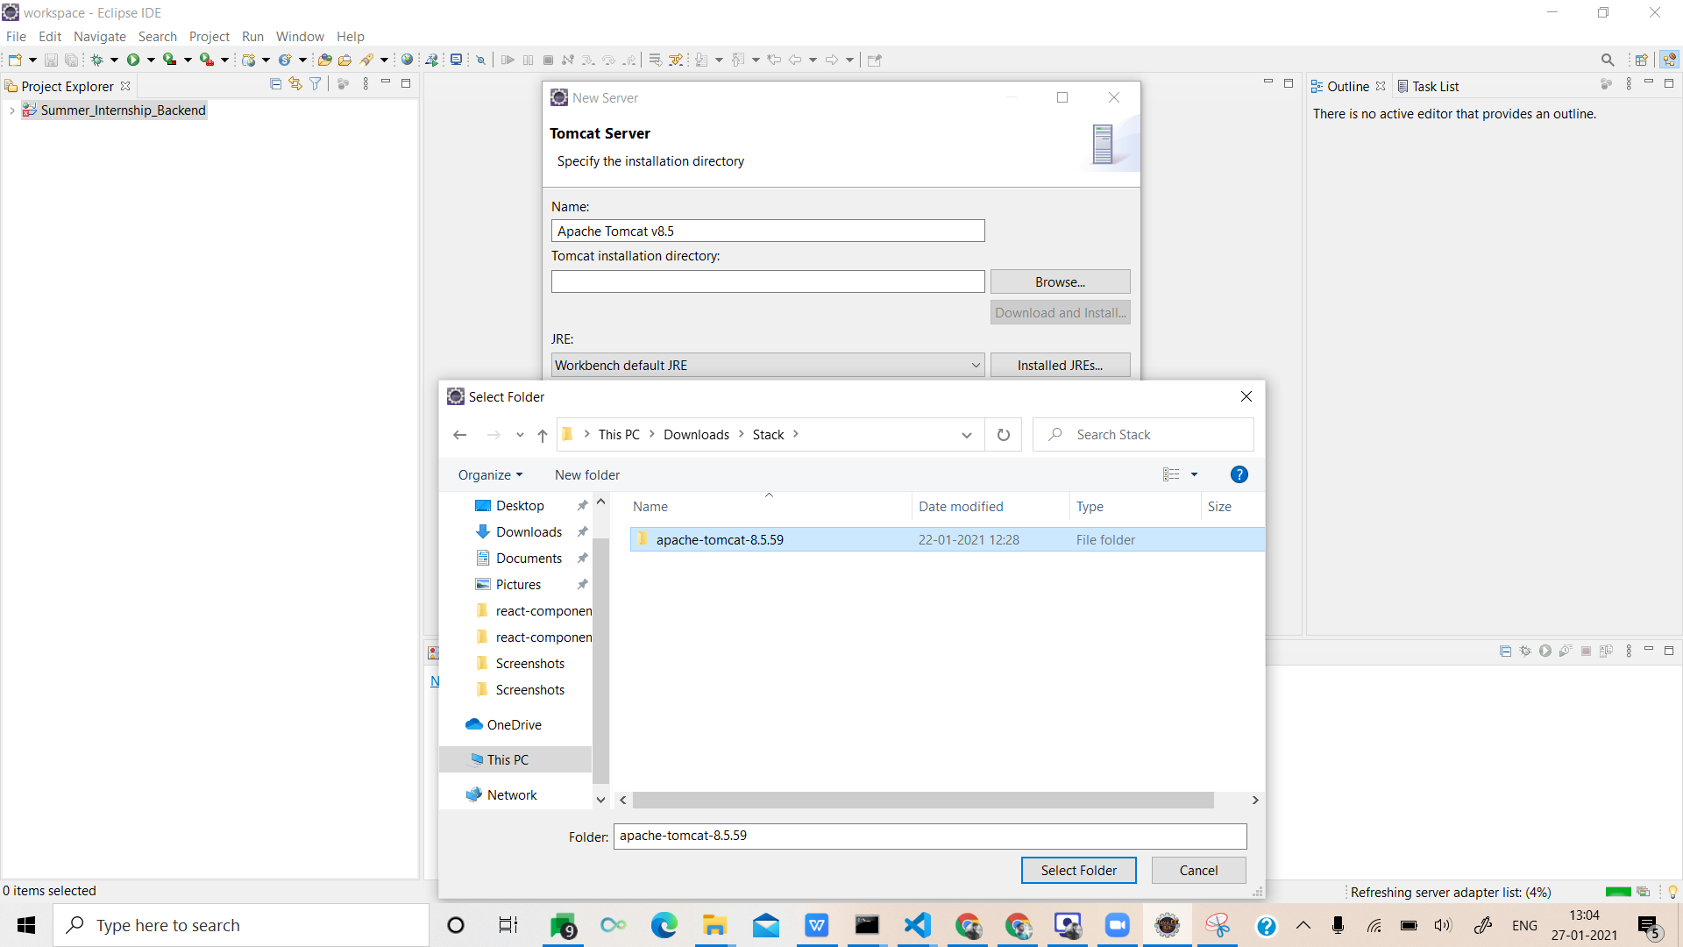  
   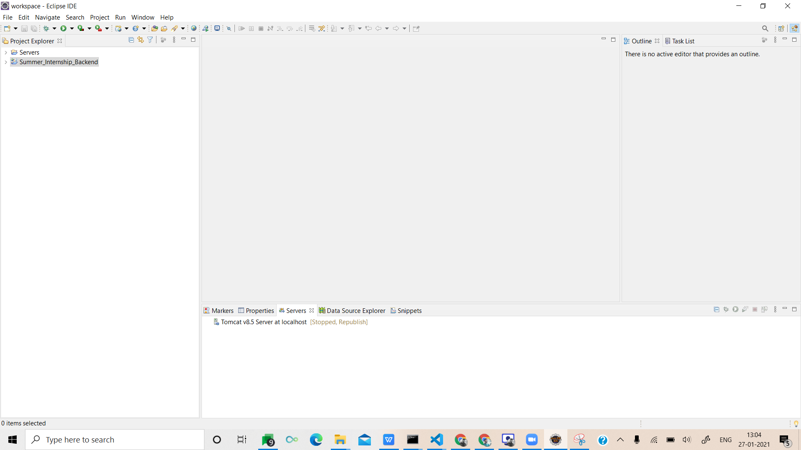
7. Right Click on the project -> Run As -> Run On Server -> next -> Finish.  
   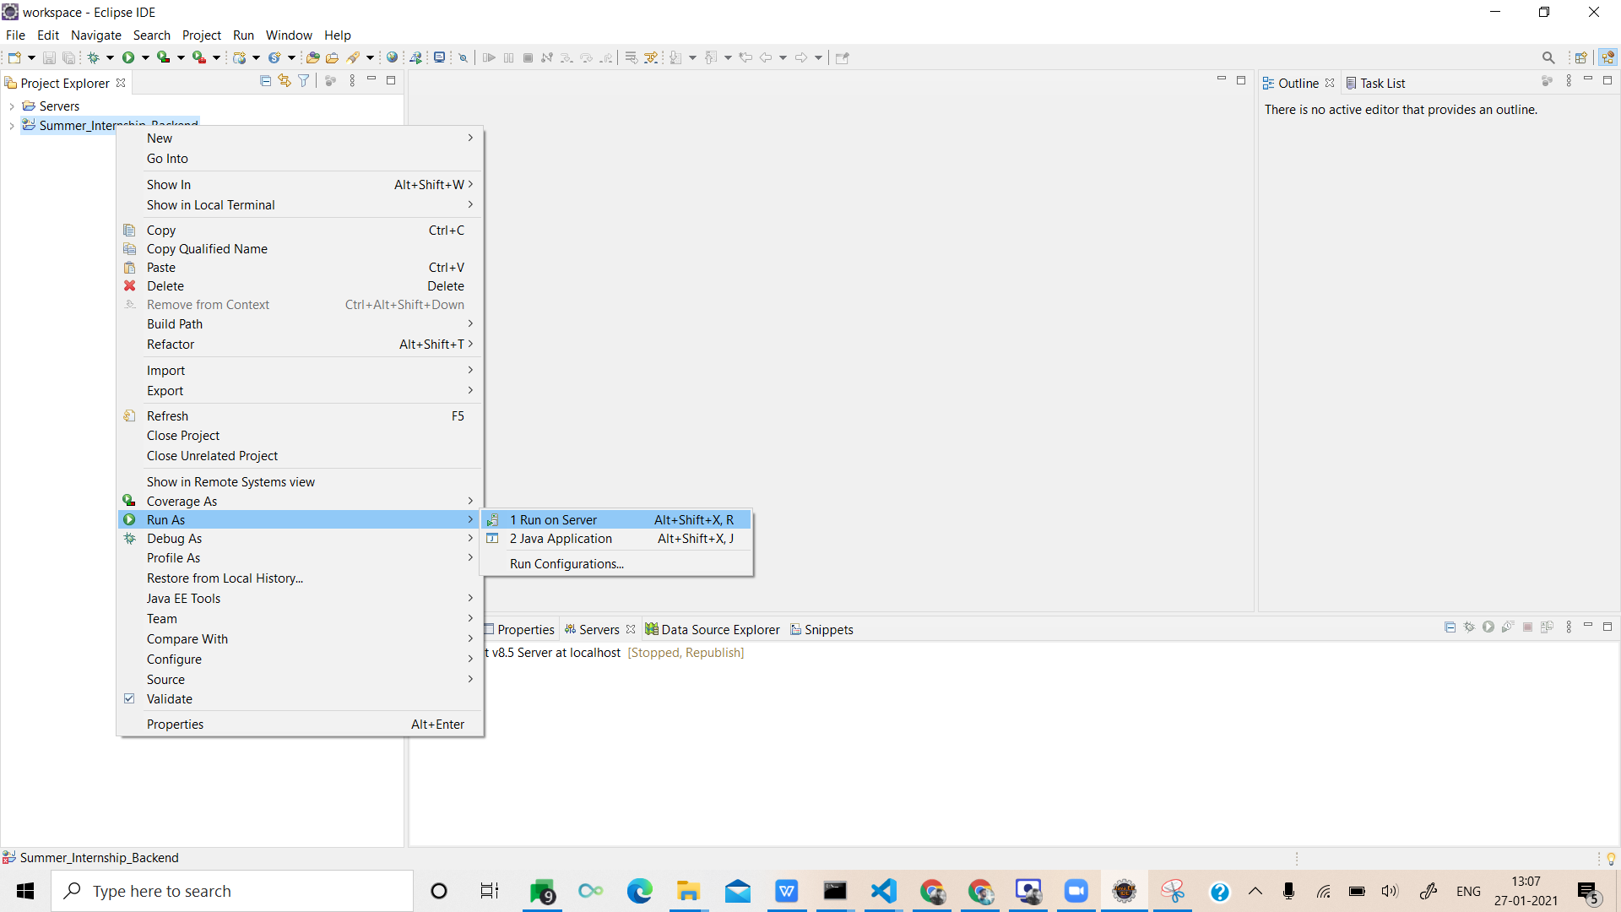  
   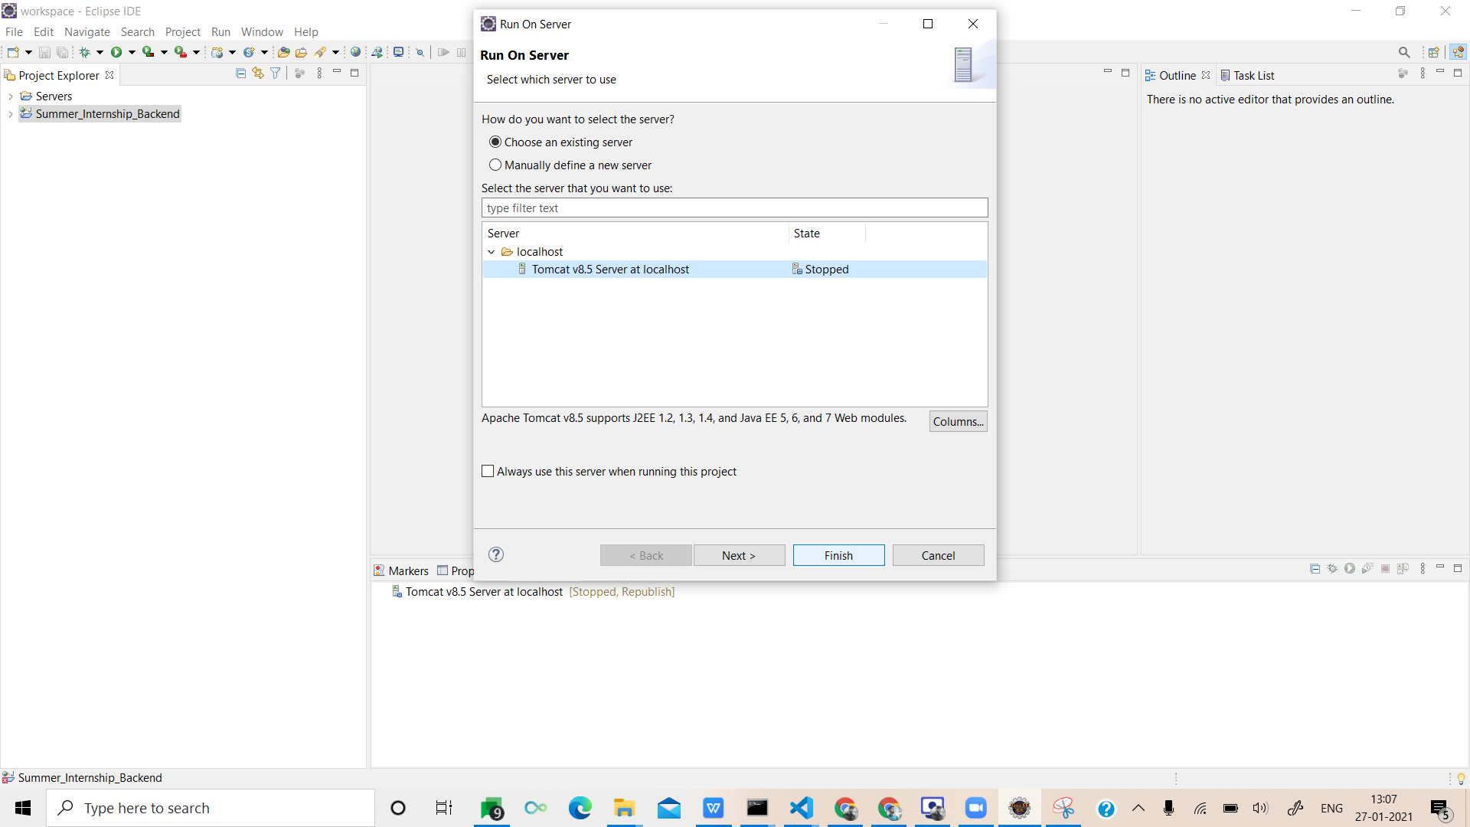
8. Open server.xml from the Server folder and change path to your roll number in Context tag.  
   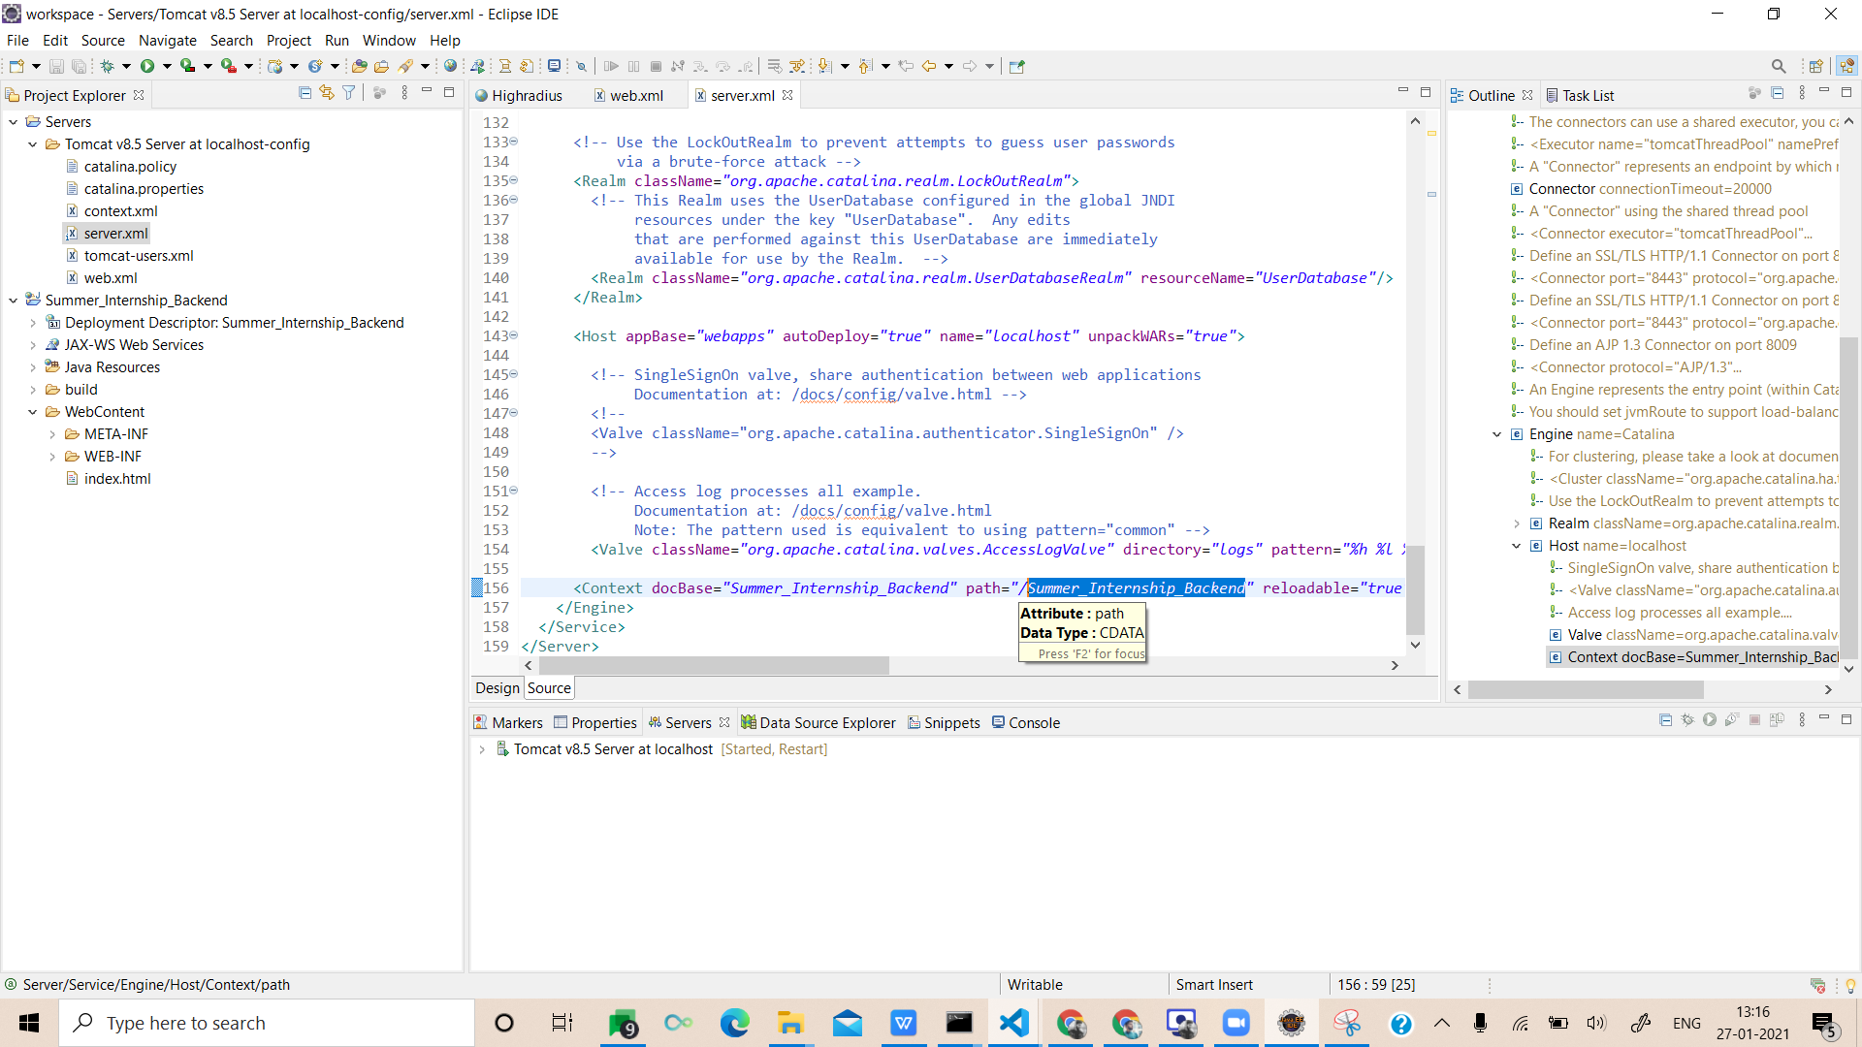  
   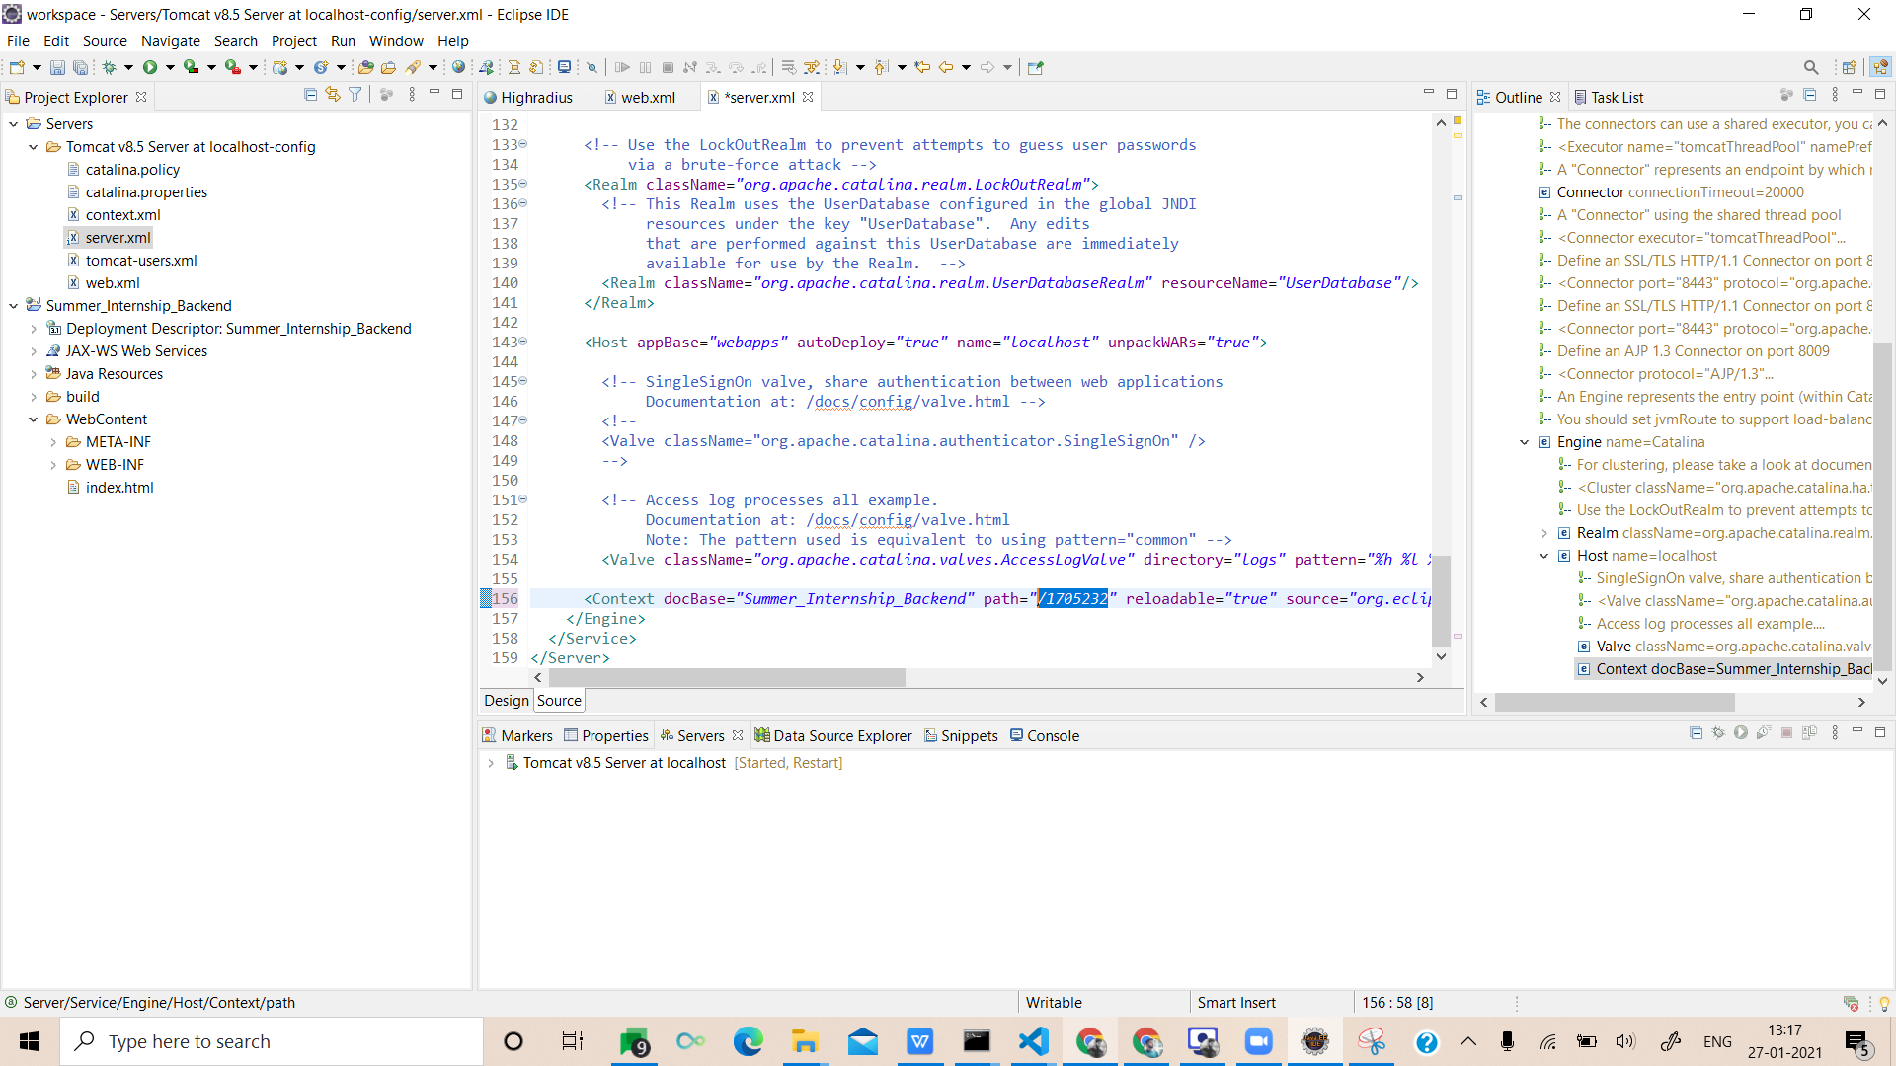
9. Stop the running server and start the server again and check the url. It should be “<http://localhost:8080/><YOUR ROLL NUMBER>”  
   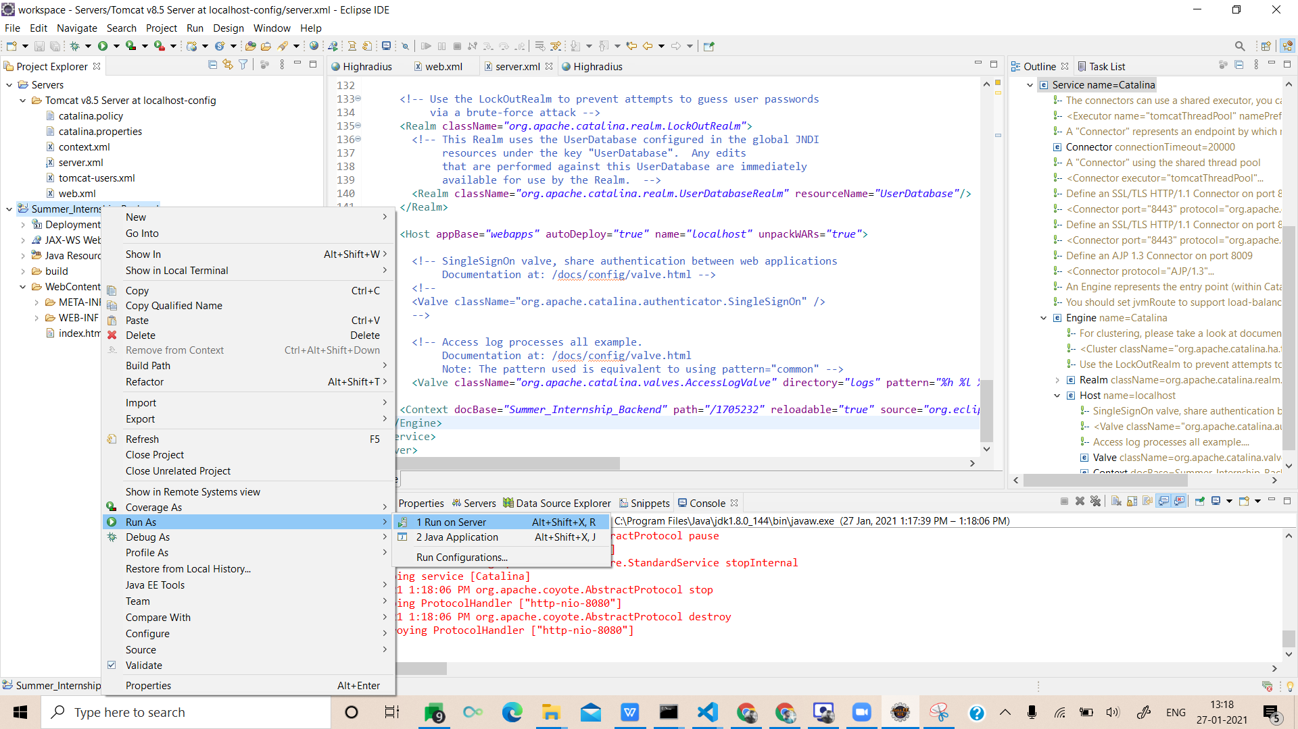  
   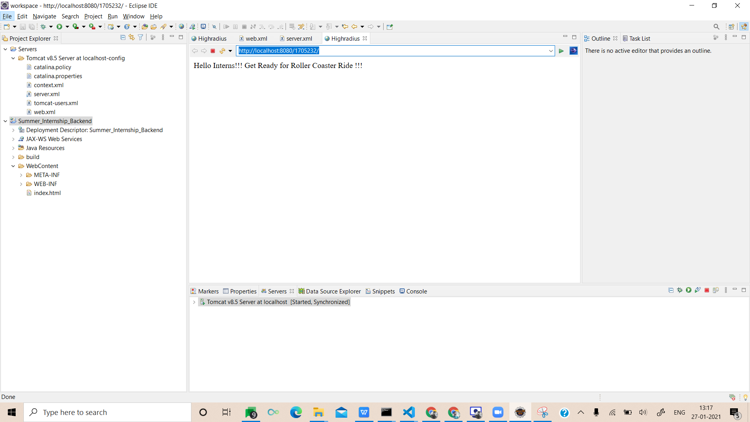
10. Best Of Luck ! 👍